Python Programming Assignment: Mastering Data Types

Student Name: Faraz Ul Hassan Jehangiri
Date: 21/jan/2026

Objective
To demonstrate proficiency in identifying, declaring, and manipulating Python’s core data types, including Integers, Floats, Strings, Booleans, Lists, Tuples, and Dictionaries.
Part 1: Identification & Declaration
Complete the table below by providing the correct Python code to declare the value and identifying its data type using the type () function.
Answer:
S.No | Value | Python Declaration | Data Type Name
1. | 100 | X=100 | Int
2. | 95.5 | X=95.5 | Float
3. | “Hello World” | X=”Hello World” | String
4. | True | X=True | Boolean
5. | [1,2,3] | X=[1,2,3] | list

Part 2: Coding Challenges
1. The String Manipulator
Create a string variable named course with the value "Python Programming". Write the code to perform the following:
1. Print the length of the string.
2. Print the first character of the string.
3. Convert the entire string to uppercase.

Answer:
Code:
Course="Python Programming"
print(len(Course))
print(Course[0])
print(Course.upper())

Output:
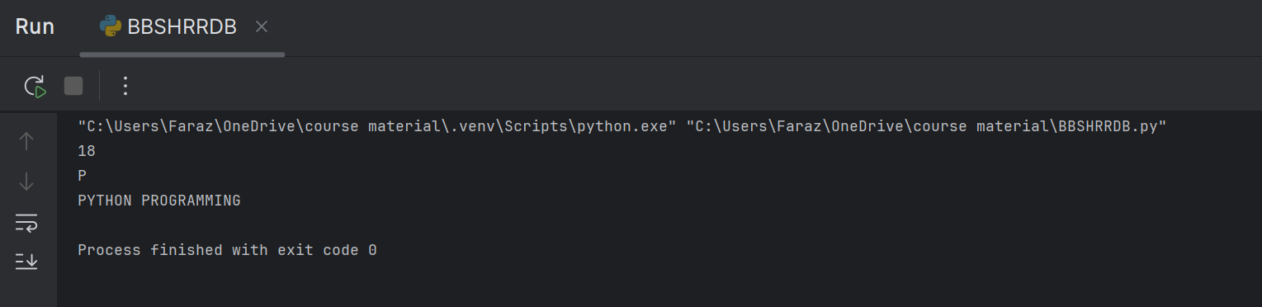
2. The List Organizer
Create a list called fruits containing: "apple", "banana", and "cherry".
1. Add "orange" to the end of the list.
2. Change "banana" to "blueberry".
3. Print the final list.
Answer:
Code:
lst=["apple","banana","cherry"]
lst.append("orange")
lst[1]="blueberry"
print(lst)

Output:

3. Simple Math & Logic
Declare two variables: a = 15 and b = 4.
1. Create a third variable result that stores the result of a divided by b.
2. Is result an integer or a float? Write a comment in your code with the answer.
3. Write a Boolean expression that checks if a is greater than b.
Answer:
Code:
#the result is a float
a=15
b=4
result=a/b
r=a>b
print(r)

Output:
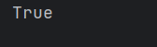
Part 3: Data Structures (Dictionaries)
Create a dictionary named student info with the following key-value pairs:
- "name": Your Name
- "age": 20
- "is_enrolled": True
Task: Write the code to print only the value associated with the "name" key.
Answer:
Code:
This_Dict={"Name":"Faraz Jehangiri",
"age":20,
"Is Enrolled":True
}
print(This_Dict["Name"])

Output:


Part 4: Short Answer
1. Explain the difference between a List and a Tuple in one sentence.
Answer: list is changeable while a tuple is unchangeable.
2. What is the result of the following expression: type (10 / 2)?
Answer: float

Submission Instructions
- Save your Python code in a .py file.
- Paste your code and output screenshots into this Word document.
- Submit the final document by the deadline.

